MZIMBA NORTH DISTRICT EDUCATION
2025/26 FORM 2 END OF TERM ONE EXAMINATIONS
MATHEMATICS
MARKING KEY
(100 Marks)

1.(a) Simplify $2k-7f-4(2k-3f)$ (3 Marks)
Solution
2k-7f-8k+12f [1]
2k-8k-7f+12f [1]
-6k+5f [1]
(b) Evaluate 1011₂ + 405₁₀ leaving your answer to base 10 (4 Marks)
Solution
Convert 1011₂ to base 10
1x2³ + 0 x2² +1 x2¹ +1 x2⁰ [1]
8+0+2+1 [1]
11₁₀
11₁₀ +405₁₀ [1]
416₁₀ [1]
2. (a) Expand $(3d-2)$² (3 Marks)
(3d-2)(3d-2) [1]
9d²-6d-6d+4 [1]
9d²-12d+4 [1]

(b) Make n the subject of the formula $T=a+\left(n-1\right)d$ (3Marks) T-a=(n-1)d [1]
$\frac{T-a}{d}=\left(n-1\right) [1]$
$n=\frac{T-a}{d}$ +1 [1]
3. Show that 3 ,4 and 5 are Pythagorean triple (3 Marks)
$$3^{2}+4^{2}=5^{2} [1] (pythagras theorem)$$
9 + 16 = 25[1] , 25 = 25[1] LHS =RHS 3, 4 and 5 is Pythagorean triple
4. The following shows length in cm of samples of 50 seedlings found in a certain seed bed.
2 | 7 | 4 | 3 | 2 | 6 | 5 | 5 | 4 | 6
5 | 7 | 3 | 5 | 4 | 7 | 3 | 4 | 3 | 2
4 | 6 | 4 | 7 | 5 | 3 | 5 | 5 | 6 | 3
6 | 5 | 7 | 6 | 6 | 4 | 6 | 6 | 5 | 7
5 | 4 | 2 | 7 | 4 | 3 | 6 | 5 | 5 | 7

- Construct a frequency table. (4 marks
Length (x) | Tally | Frequency (f) | fx
2 | /// | 3 | 6
3 | //// // | 7 | 21
4 | //// //// | 9 | 36
5 | //// //// // | 12 | 60
6 | //// //// | 10 | 60
7 | //// / | 6 | 42
 |  | ∑f= 47 | ∑fx =225

(b) Use it to calculate the mean length of the seedlings.
(3 Marks)
Mean =$\frac{∑fx}{∑f}$ [1]
=$\frac{225}{47}$ [1]
=4.8(1dp) [1]

5 Figure 1 below shows a rectangle PQRS
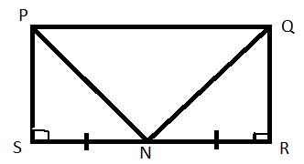
If SN=RN, show that triangle PSN is congruent to triangle QRN (4 Marks)
SN=RN (Given) [1]
<PSN=<QRN – 90◦(int. <s of a rectangle) [1]
PS=QS (sides of a rectangle) [1]
▲PSN≡▲QRS (SAS) [1]
6. Factorize $6m$ ²$+13m+6$ (4 Marks)
(6m² +4m)(9m +6) [2]
2m(3m+2) +3(3m+2) [1]
(2m+3)(3m+2) [1]

7. The n^{th} term of a sequence is $\frac{1}{n+2}$ and the last term is 0.1. Find the number of terms of the sequence
(5 Marks)
nth term = last term
$\frac{1}{n+2}$ = 0.1 [1]
1= 0.1 (n+2) [1]
1-0.2 = 0.1n [1]
0.8=0.1n [1]
n= 8 [1]
- Given the equation $5x-y=8.$ Find:
- $y$ intercept (3 Marks)
5x –y = 8 (make y the subject of the formula) [1]
5x-8 =y (y intercept is when x=0) [1]
5 (o)-8=y y=-8 answer [1]
- Gradient of the equation
(2 Marks)
Gradient is the coefficient of x. [1]
Gradient =5 answer [1]

- A residence plot in town appreciates in value at the rate of 15% per annum. Its current value is k3,500,000. Calculate its value after 2 years (5 Marks)

Current value =K3,500,000
Value at end of the first year= K3,500,000 +$\frac{15\%}{100\%}$ X K3,500,000. [1]
=K3,500,000+K525,000
=K4,025,000 [1]
Value at the end of the second year
=K4,025,000 + + $\frac{15\%}{100\%}$ x K4,025,000 [1]
=K4,025,000 +K603,750 [1]
=K4,628,750 [1]

- Solve the equation $\frac{5x+2}{4}-$ $\frac{3}{2}=\frac{7x+1}{3}$ (5 marks)

$\frac{2 x \left(5x+2\right)-2\left(3\right)}{4}=\frac{7x+1}{3}$[1]
$\frac{10x+4-6}{4}$ =$\frac{7x+1}{3}$[1]
3 x (10x +4 -6) =4 x (7x +1)[1]
30x-6 =28x+4
30x-28x =4+6[1]
2x = 10
X=5 answer[1]

11. In the following MN is parallel to PR,angle QPR= 63⁰ and angle MNP= 40⁰
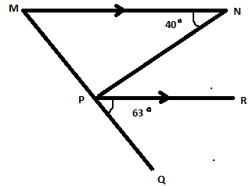
Calculate the size of angle MPN (4 Marks)
$<MNP= <$NPR=40⁰ (alt angles)[1]
<NPR + <QPR +<MPN =180⁰ (Adjacent angles/ angles in a straight line)
40⁰ + 63⁰ + < MPN =180⁰ [1]
103⁰ + < MPN = 180⁰ [1]
<MPN = 180⁰ - 103⁰
< MPN = 77⁰ [1]

12. Solve the following simultaneous equation
$2m-n=4…………..\left(i\right)$
$2m+3n=-4………….(ii)$ (4 Marks)

2m-n = 4……………(i)
-(2m +3n =-4 ……………….(ii) (Subtract equation2 from equaton 1) [1]
-4n=8 (Di(Subtract equation2 from equaton 1)
-4n=8 (Divide both side by -4)
n =-2 (Substute n as -2 in equation 1) [1]
2m – n =4
2m-(-2) =4 [1]
2m=4-2
2m =2 m=1 [1]
When n=-2, m=1
13. Factorize $3x$ ²$-27$ (4 marks)

3[x² -9]…. [1]
3[(x²⁾ –(3)²]…. [1]
3[(x-3)(x+3)]…. [2]

14. The sum of the interior angles of a regular convex polygon is $2340°$. Calculate the value of each exterior angle of the polygon.
(5 marks)
Solution
Sum of interior angles =(2n-4)x 90 (where n is the number of sides)
2340⁰=(2n-4)x90⁰ ( Divide both side by 90⁰)
26 =2n-4
30=2n
n=15 (number of sides =15)
size of each exterior angle =2340devide by15
=156. Answer

15. (a) Figure 3 below shows a quadrilateral MPON.
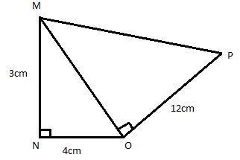
Calculate the length of MP (4 marks)

MO² = MN² +NO²
= 3² + 4² [1]
= 9 + 16
= $\sqrt{25}$
MO = 5[1]
MP² = MO² + OP²
= 5² +12² [1]
= 25 + 14
$=\sqrt{169}$
MP = 13 [1]

(b) A family of 6 people uses 30 kg of flour in a month. If 2 visitors joined them for a month, how many kilograms of flour would be required for that month?
(4 marks)
If 6 people = 30kg
6+2 = 8 people[1]
8 people = more
=$\frac{8 people}{6 people}$ x30kg [1]
=$\frac{8x30kg}{\begin{aligned}6 \\ \end{aligned}}$
=$\frac{240}{6}$kg [1]
=40kg answer
16. The following Venn diagram shows numbers of elements for set M and Q
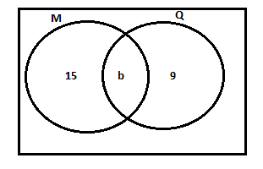
Given that n(MUQ) =34, Find n(M∩Q)
(4 marks)
34= 15 + 9 + b [1]
34 = 24 + b[1]
34 – 24 = b
10 =b [1]
n(MՈQ) = 10 [1]

17. The diagonals of a rhombus are 10cm and 24cm respectively. Calculate the length of the sides of the rhombus (5 marks)
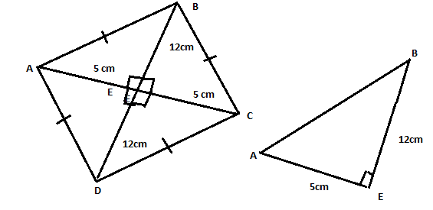 Diagram sketching [2]
AB² =AE² + EB²
= 5² +12² [1]
= 25 + 14
$=\sqrt{169}$
MP = 13 [1]
The sides of a Rhombus is 13 cm [1]

18. Figure 4 below shows a cylindrical steel bar whose length is 7cm and diameter of 4cm.
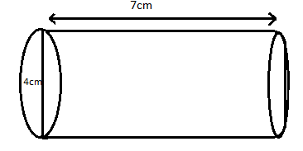
Calculate the volume of the cylindrical steel bar (Take π =3.14), leaving your answer to 2 significant figure.
V=πr²h [1],
= 3.14 x 2² x7[1]
=3.14 x 4 x x7
=87.92[1]
=88cm^{3[1]}
(4 Marks)

19. Using a ruler and a pairs of compasses only, construct in the same diagram a triangle ABC such that AB = 6cm, AC = 5cm and angle CAB = $60°$ (5 Marks)
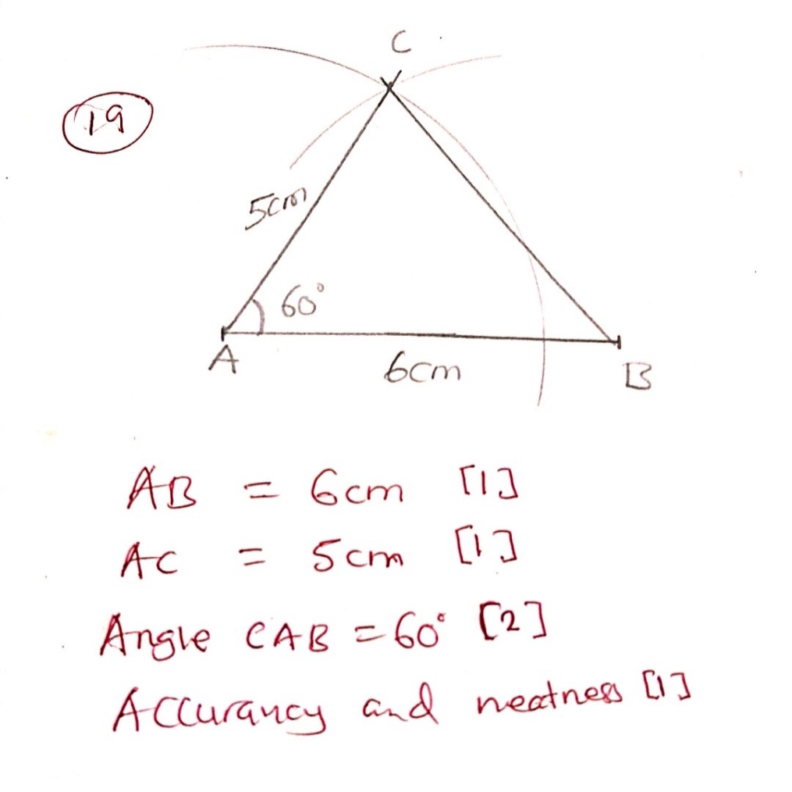

20. Table 1 below shows the values of x and y for equation$y=2-x$.
X | -3 | 0 | 2
Y | 5 [1] | 2 | 0
- Complete the table of values for equation $y=2-x$ (1 Marks)

- Using a scale of 2cm to represent 2 unit on both axes, draw the graph of $y=2-x$ on the graph paper provided (3 Marks)
- Using your graph, solve the simultaneous equations for $y=2-x$ and $y=2$ (2 marks)

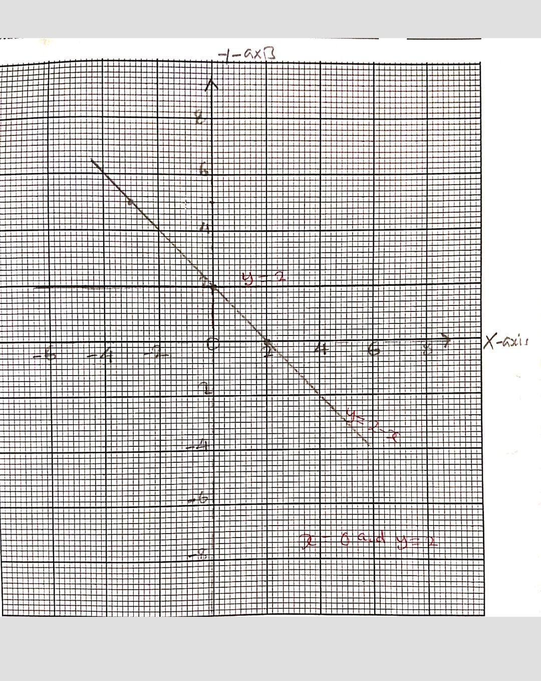
The end of question paper

